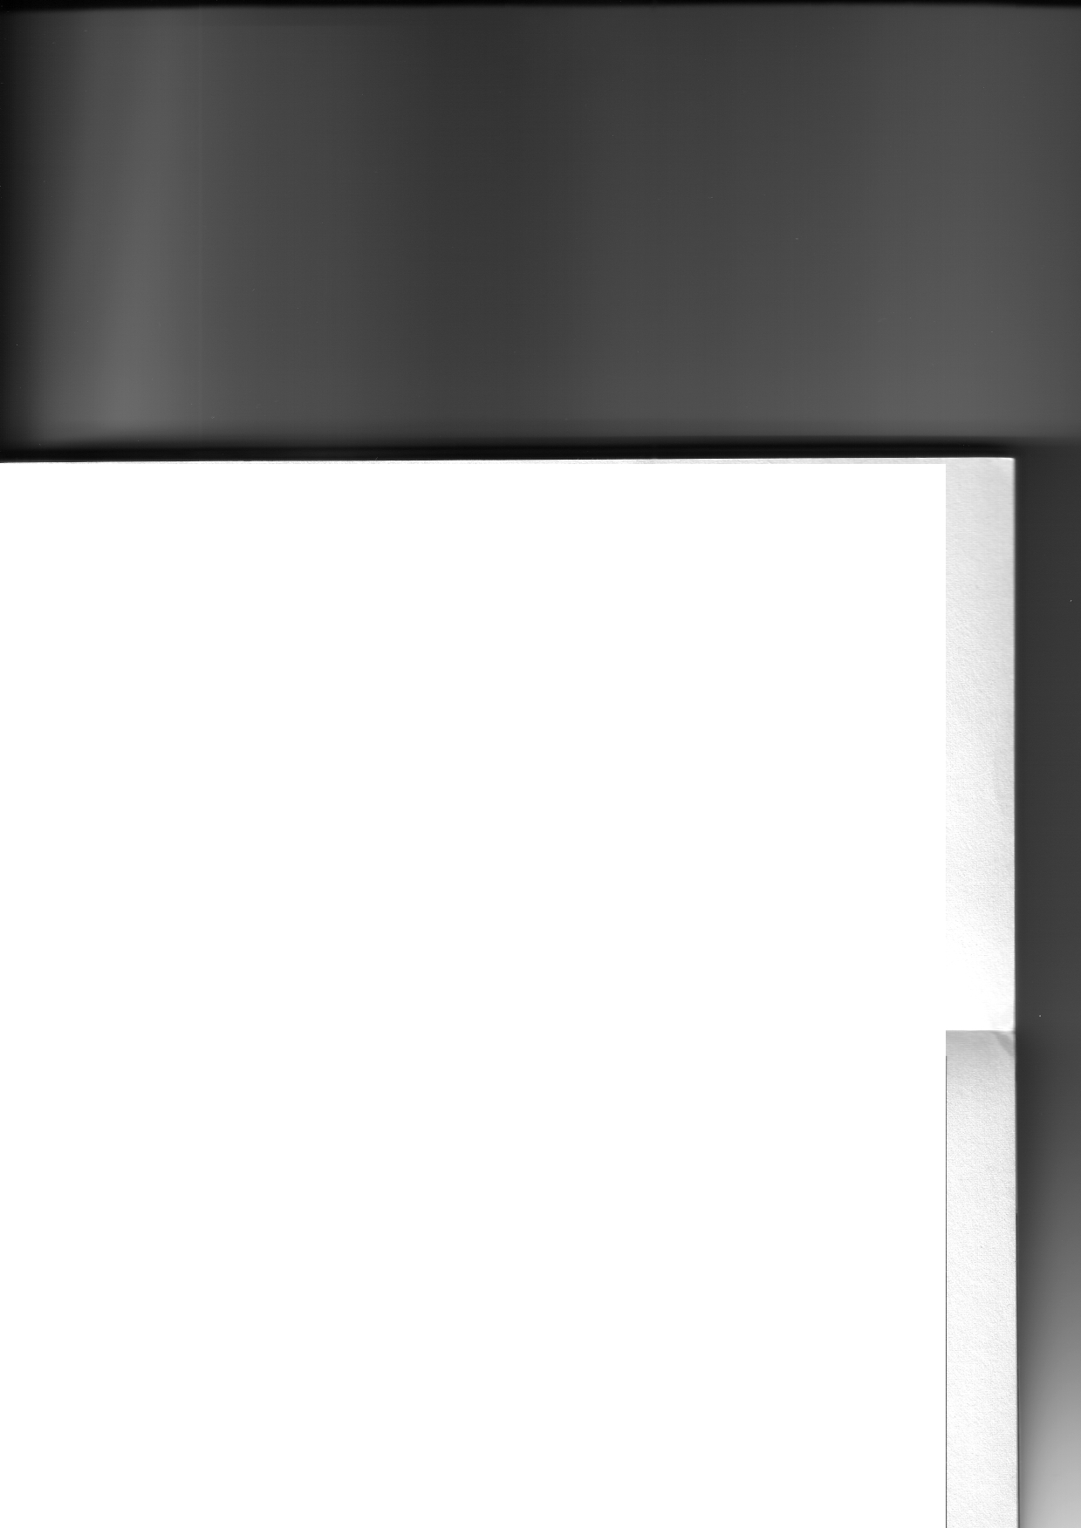
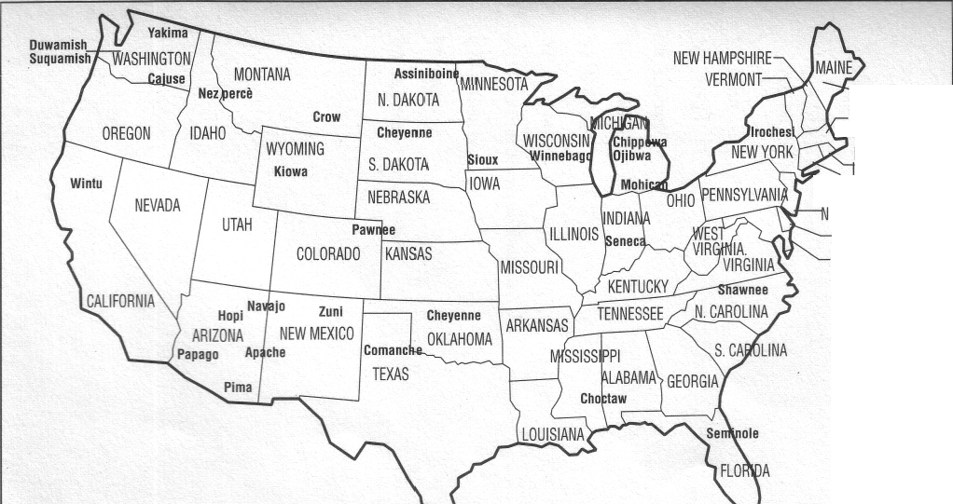
Mohawk MASSACHUSETTS RHODE SLAND CONNECTICUT EW JERSEY DELAWARE MARYLAND

